|  |  |  |  |  |  |  |
| --- | --- | --- | --- | --- | --- | --- |
| **Test Name** | | | Crown & Anchor Bug 2 Retest after Fix | | | |
| **Use Case Tested:** | | | Player cannot reach betting limit | | | |
| **Test Description:** | | | Run the game and observe if player’s balance remains at 5 dollars by game end with limit set to 0 | | | |
| **Pre-conditions** | | | Single run of main() method to produce 100 games | | | |
| **Post-conditions** | | | n/a | | | |
| **Notes:** | | **Given the large number of turns in a single run (100 games x up to 100 turns), only the first 10 positive results will be observed and recorded.**  **No test data are available to use as the main() method hard-codes the input data.** | | | | |
| **Result (Pass/Fail/Warning/Incomplete)** | |  | | | | |
|  | **TEST STEP** | | | **EXPECTED TEST RESULTS**  **ACTUAL TEST RESULTS** | P | F |
|  | Observe if the player has 5 dollars remaining at end of game (continue until 10 observations confirm this). | | | Player has zero dollars remaining in balance at end of a game.  Actual results confirm the hypothesis – see screenshot 1 below. |  |  |
|  | Observe if the player has 0 dollars remaining at end of game (continue until 10 observations confirm this). | | | Player can have zero dollars remaining in balance at end of game.  Actual results confirm the hypothesis – see screenshot 1 below. |  |  |
|  | Observe if player has an amount greater than 5 dollars remaining at end of game (continue until 10 observations confirm this). | | | Player can now have a balance amount greater than 5 dollars remaining at end of game.  Actual results confirm the hypothesis – see Screenshot 2 below. |  |  |

|  |  |  |  |  |  |
| --- | --- | --- | --- | --- | --- |
| **Test Data Table** | | | | | |
|  | **1** | **2** | **3** | **4** | **5** |
| Player Name | “Fred” (set by default) |  |  |  |  |
| Games played | 100 (set by default) |  |  |  |  |
| Turns played | Until balance is 0 (set by default) |  |  |  |  |

# Screenshots

Screenshot 1:

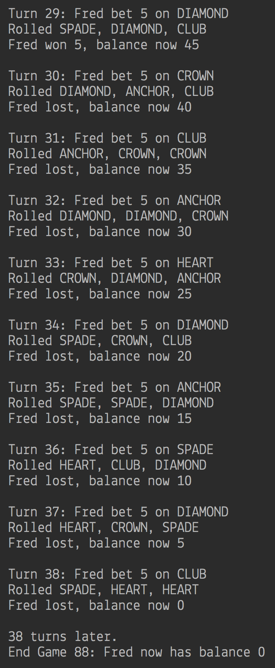

Screenshot 2:

